

Automated Support Infrastructure Asset survey and Assessment Service User Guide

Table of Contents

Overview 3
Setting up the Asset Survey Scrip configuration 4
Setting up the site record for an asset survey and assessment customer 6
Client Setup 8
ASI client installation at asset survey and assessment customer 11
Defining a restricted user id for an asset survey and assessment customer on your ASI server 11
Adding a site name record on the ASI server manually 14
Defining and running asset reports for an asset survey and assessment 17
Running an asset report 17
Customizing an asset report 21
Changing the information contained in an asset report 21
Identifying the asset query used by a report 21
Modifying an asset query 23
Editing an asset report to change the asset query it uses to retrieve asset information 26
Base Scrip configuration list 29

Overview
You can use ASI to provide an automated one-time asset survey and assessment for a prospective customer. This activity can be packaged as a stand-alone service that requires a minimum amount of labor on your part while delivering concrete value to your customers.
Overall, the process for delivering the ASI asset survey service consists of the following activities:
- Set up a Scrip configuration on the installation server that activates only Scrip 61 (system survey), and Scrips 22 and 23 (event and asset logging). Let’s say you call this Scrip configuration Asset Survey. This is a one-time activity that should take no more than five minutes.
- On the installation server, set up a site record for the customer site where you will perform the asset survey service. Assign the Asset Survey Scrip configuration at start-up. Based on the exact nature of the service offered to the customer, you should also select a suitable delay between the start-up and follow-on phases, and the appropriate action to be performed at the start of the follow-on phase (e.g. have the ASI client remove itself, go dormant, or in full production mode). You will perform the site record definition activity for each customer you provide the asset survey service to. It should take no more than five minutes per site.
- Install the ASI client at the customer site using the site registration code either interactively, or adding it as a run-time parameter to the ASI client installation executable command line. This activity should take no more than 1-2 minutes per system. If you use login scripts or the AT command, installation will be automated. Setting up the login script or AT command should take no more than 30 minutes per site.
- On your ASI server, define a restricted user id for your customer. Users logging onto the ASI server using the restricted user id will have access only to reports with information from their site published on the ASI information portal. They will not be able to access any ASI server function other than viewing reports on stored on the ASI information portal. You will perform this activity for each customer you provide the asset survey service to. It should take no more than five minutes per site.
Please note that you should set up the restricted user after having installed the ASI client at a customer site as only then you will be able to assign the site to the restricted user.
- Define and produce the asset reports that represent a key deliverable of the asset survey service. Many sample reports are available on the ASI server. You could use the following reports as a starting point:
- Master Network Software List
- Network CD-ROM List
- Network Equipment Hard Drive List
- Network Equipment Hard Drive List - II
- Network Equipment Operating System List
- Network Equipment RAM Table
- Network Equipment Processor Table
- Software Inventory - All Devices
- Software Inventory - Servers
- Software License Numbers - All Devices
- Software License Numbers – Servers
You should not hesitate to contact HandsFree Networks if you need help in changing the reports or the underlying asset queries, or to define new ones. We’ll be glad to do that work.
Please note that by default, the above reports are configured to be published on the information portal. If you want to receive them by e-mail in order to be able to package them with other information or reproduce them in Adobe Acrobat PDF format, you can change Report output in the report definition to e-mail.
Defining the reports that meet your requirements for conveying information and value to your customer will probably take a few iterations. Overall, this process should not take more than a couple of hours, with occasional fine-tuning over time. Initiating production of the reports themselves, either on demand or on a schedule should not take more than 5-10 minutes per site.

Setting up the Asset Survey Scrip configuration
- Log onto the Scrip configurations module on the ASI installation server as <master user>. Open a browser window and type:
https://www.nanoheal.org/main/install/strtlist.php
- Enter your master user id and password. After successfully logging on, the Scrip Configurations page will be displayed (See figure below).
Please note that you can reach the Scrip Configurations page by clicking on the Scrip configurations link located at the top right-hand corner of every ASI installation server page to the right of the installation: label, or on the Scrip configurations link under the Installation Management header on the Welcome page of the ASI installation server.
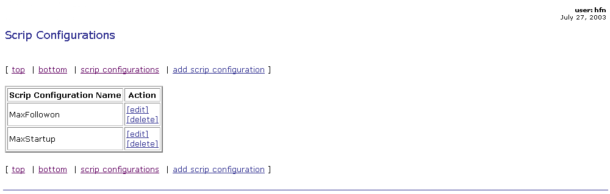
- On the Scrip Configurations page, click on the add Scrip configuration link. The Add Scrip Configuration page will be displayed (See figure below).
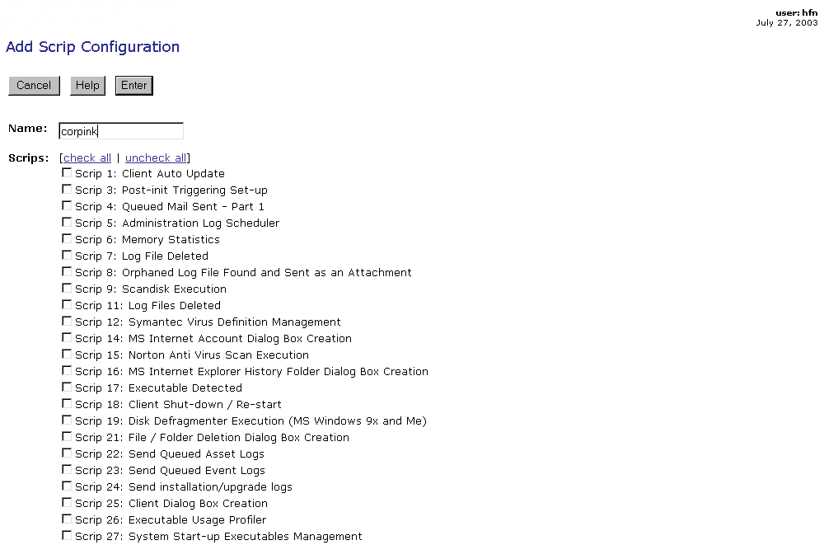

- Enter the asset survey and assessment Scrip configuration name in the box to the right of the Name: label. For example, you could call it Asset Survey
- Select Scrips 22, 23, and 61 by clicking in the box to the left of the entry for each Scrip.
- Click on the  button at the bottom of the page. The Adding Scrip Configuration page will be displayed (See figure below).
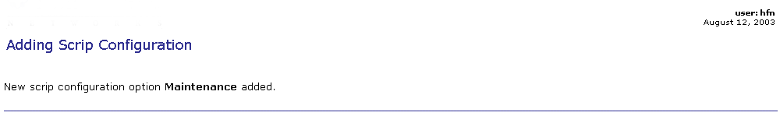

Setting up the site record for an asset survey and assessment customer
- Log onto the sites management module on the ASI installation server as <master user>. Open a browser window and type:
(https://www.nanoheal.org/main/install/sites.php?action=list).
- Enter your master user id and password. After successfully logging on, the Sites page will be displayed (See figure below).
Please note that you can reach the Sites page by clicking on the sites link at the top right-hand corner of every page of the ASI installation management facility, to the right of the installation: label, or on the sites link under the Installation Management header on the ASI installation management facility’s Welcome page.
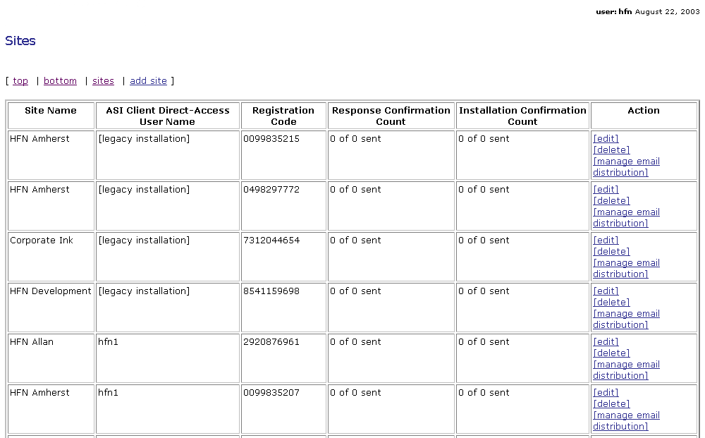
- Click on the [add site] link on the Sites page (above or below the Sites table). The Add Site Installation and Deployment Information page where you add the information for the new site will be displayed (See figure below).
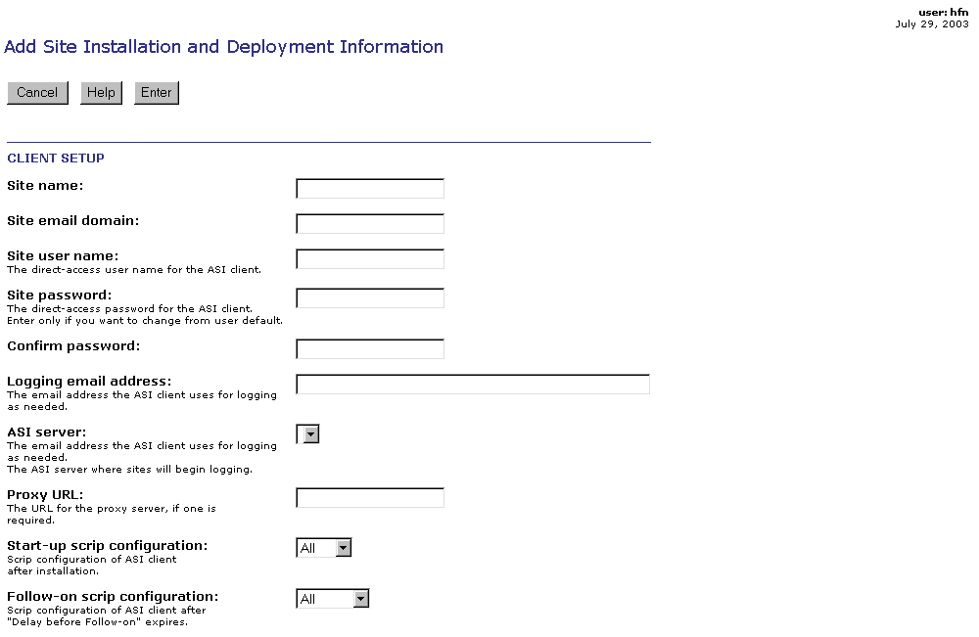
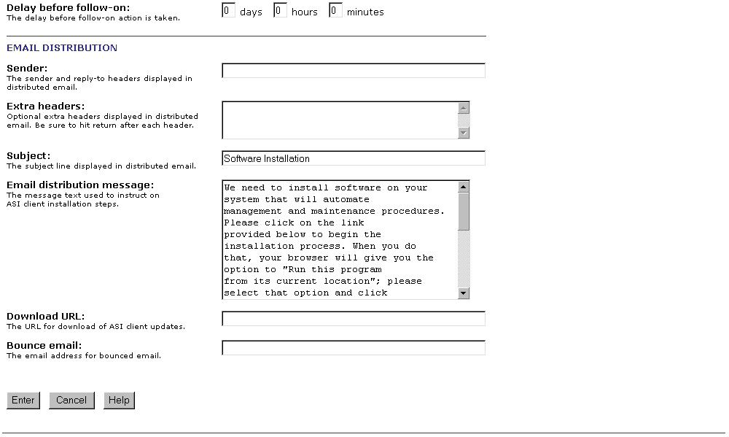
- Enter the required information as follows:

Client Setup
- Site name – the full name of the site used on the ASI server to group the logs generated by the ASI client software at the site. Spaces are allowed. The total number of characters cannot be greater than 255. When creating the name of a site you should avoid using the following characters:
- &
- , (comma)
- . (period)
For example, "Marx Brothers Inc"
- Site email domain – This is the e-mail domain name of the site. It is used by the ASI client in case it needs to communicate with the ASI server via e-mail.
- Site user name – Logged in as this user, you will be able to directly access the ASI client on any system at the site via the client browser based interface. This User name should be a single text-only string of between x and y characters. As for Server Name you should not use &, comma, or period. For ease of use, when creating a user name you might also want to avoid using upper case letters, or a mix of upper and lower case letters in user id’s.
- Site password – this should be a single text-only string of between x and y characters. For increased security, as you enter the password it is displayed as a string of *
- Confirm password – to minimize the chance of making a data entry error, you are asked to re-enter the content entered in the Password field in this field. For increased security, as you enter the password it is displayed as a string of *
- Logging email address – this is the site specific email address that is used by the ASI clients at a site when they need to directly send email to the ASI server. This is currently only used when email logging is enabled on the ASI client. By default it is not.
- ASI server – From this pull-down list you select the site specific ASI server used by ASI clients at the site. Clicking on the [edit servers] link to the right of the entry takes you to the ASI Servers page where you can edit the information for an existing ASI server or add information for another one.
- Proxy URL – If no proxy server is used at the site, leave this entry blank. If a proxy server is used at the site, please enter the site-specific address of the proxy server and the port it uses. If the proxy server at the site requires authentication, you should add a working user id and password to the proxy URL. The syntax of an entry in Proxy URL is:
- http://<user name>:<user password>@<proxy server name>:<proxy port>
Please remember that ASI requires that ports 80, 443, and 37 (time server) be left open for outbound communication.
- Start-up Scrip configuration – From this pull-down list you select the site specific Scrip configuration for the ASI client at the site, after installation is completed. The list includes all Scrip configurations defined for the user currently logged in, plus the two special options "All" and "None". The “All” configuration option enables all Scrips. The “None” configuration option puts the ASI client in dormant state for an indefinite period of time. In this state, the Scrips listed in the Base Scrip configuration list sub-section of this document are activated and enabled. They are sufficient to let you activate the ASI client at a time of your choosing. Clicking on the [edit Scrip configurations] link to the right of the Scrip Configurations entry takes you to the Scrip Configurations page where you can edit the information for an existing list or add another one.
- Follow-on Scrip configuration – From this pull-down list you select the site specific Scrip configuration that the ASI clients at the site will use after the start-up phase is over. The list includes all follow-on options defined for the user currently logged in, plus the three special options "All", "None", and “Uninstall. The “All” configuration option enables all Scrips. The “None” configuration option puts the ASI client in dormant state for an indefinite period of time. In this state, the Scrips listed in the Base Scrip configuration list sub-section of this document are activated and enabled. They are sufficient to let you activate the ASI client at a time of your choosing. Selecting “Uninstall” will result in removal of the ASI client from all systems where it was installed for the start-up phase. Clicking on the [edit Scrip configurations] link to the right of the Follow-on Scrip configuration entry takes you to the Scrip Configurations page where you can edit the information for an existing list or add another one.
- Delay before follow-on – in these fields you enter the site specific amount of time you want the ASI client to operate in start-up mode before moving to the follow-on phase, and applying the follow-on phase actions selected from the Follow-on Scrip configuration pull-down list. Please note that the Delay before follow-on fields have a default value of 0. Leaving the default value unchanged effectively means that the start-up and follow-on phases are one and the same.
- After you have entered and reviewed the new site information as described above click on the button. The Adding Site page (See figure below), if the site creation operation was completed successfully, or to a page with the same name and a message explaining where the error was made.
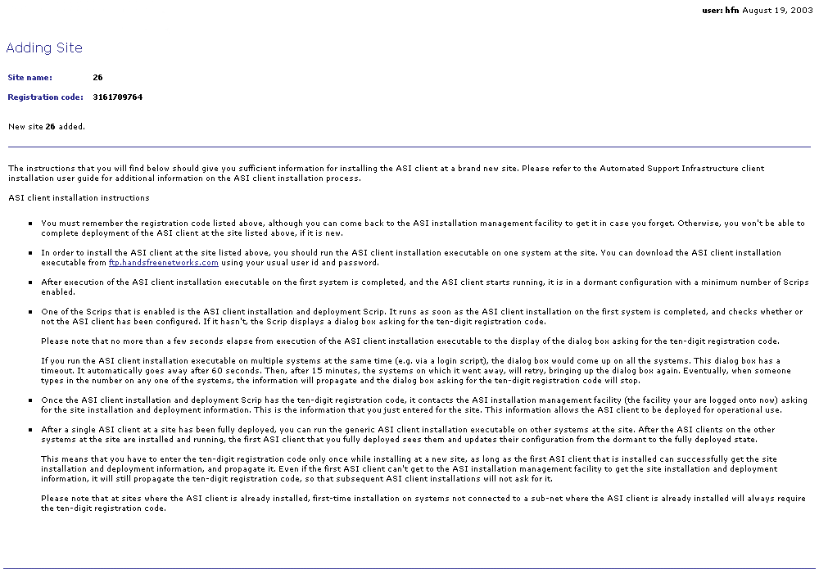
You should print out the Adding Site page as it contains the new site’s unique registration code that will be needed when installing the ASI client at the new site, and installation instructions.
- Next, click on the sites link at the top right-hand corner of the Adding Site page. The Sites page will be displayed again (See figure below).
An entry for the new site should be listed in the Sites table.

ASI client installation at asset survey and assessment customer
To install the ASI client at the new site follow the instructions in the Adding Site page, which you printed in step 5) in section Setting up the site record for an asset survey and assessment customer of this document.

Defining a restricted user id for an asset survey and assessment customer on your ASI server
To set up a restricted user, perform the following steps:
- Log onto your ASI server’s administration facility as a user with administrative rights (e.g. the master user). Open a browser window and type:
https://asiserverurl/main/acct/admin.php
Substitute asiserverurl with the URL of the ASI server your sites log to.
Please note that you can access the Admin page by clicking on the admin link to the right of the tools: label at the top right-hand corner of any of the ASI server pages.
- Enter your master user id and password. After successfully logging on, the Admin page will be displayed (See figure below).
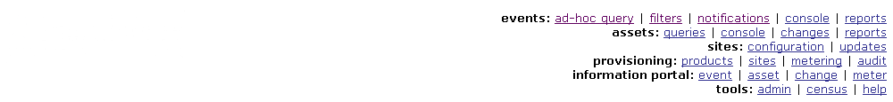
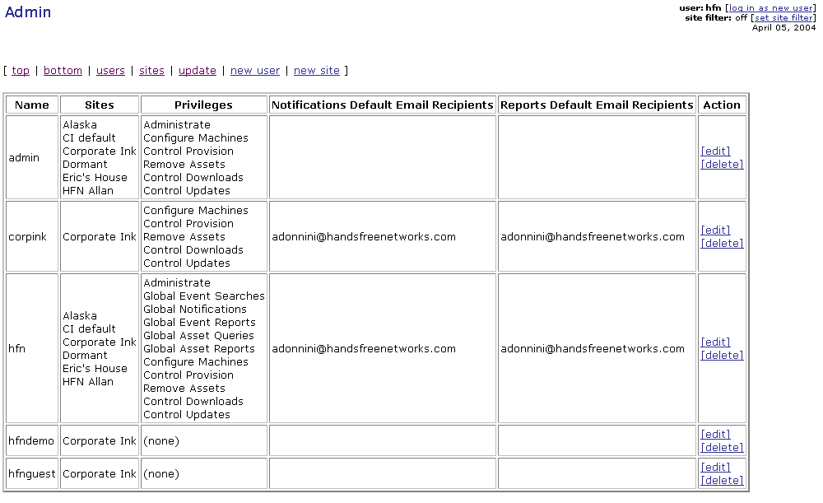
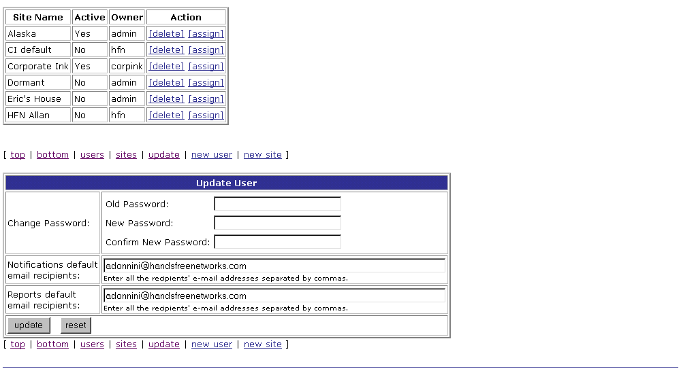
- Clicking on the new user link at the top of the Admin page right under the ASI Server page logo, will take you to the Create User page shown below.
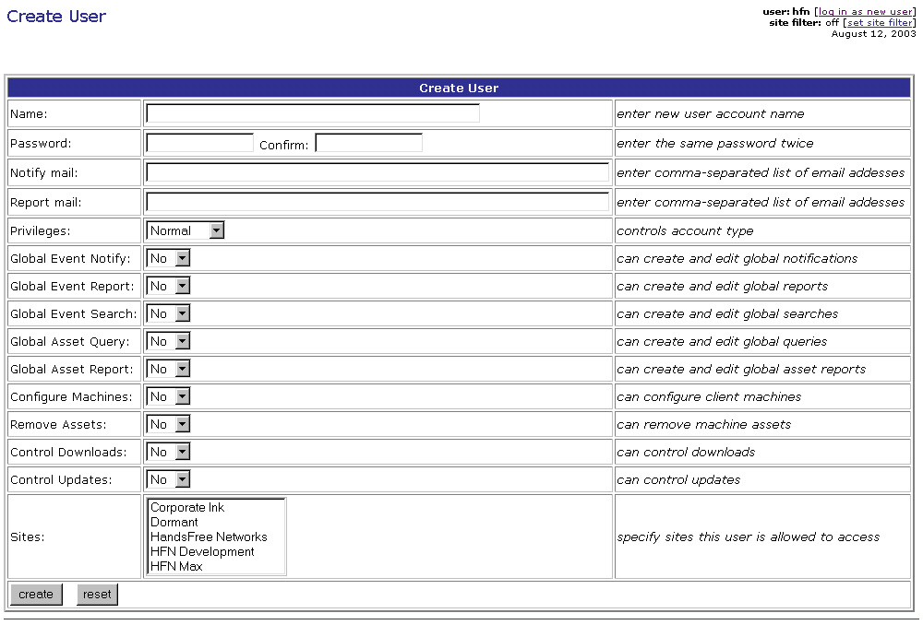
- Enter the information for the user id for accessing the ASI information portal. Enter only the information, and modify the configuration settings, described below:
- Name:
This is the user id for gaining access to the ASI information portal
- Password: and Confirm:
In these two fields you enter the password assigned to the new user. You can use any combination of letters and numbers. We recommend that a password be at least six characters long.
- Privileges – Restricted
- Sites:
Here select the name of the site whose asset survey and assessment service reports you want to give the new user access to.
You should set up the restricted user after having installed the ASI client at a customer site as only then you will be able to assign the site to the restricted user. However, you could also define the restricted user before installing the ASI client at the site. If you decide to do that, you should perform the steps described below.

Adding a site name record on the ASI server manually
If there is no site name record on the ASI server (not to be confused with the site record defined on the ASI installation server before installation of the ASI client at a site) for the site you want to give the new user access to, you will need to create the site name record(s). Clicking on the new site link at the top of the Admin page right under the ASI server page logo, will take you to the Create Site page (See figure below).
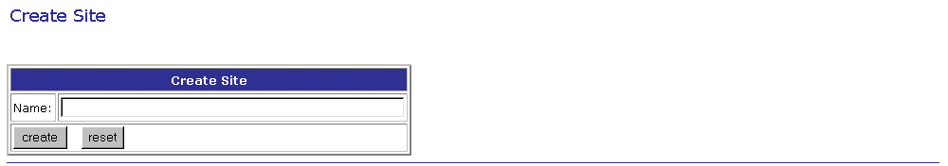
Enter the name of the site making sure that it is exactly the same as the name of the site entered in the site’s site record on the ASI installation server.
Click on the  button. The Creating Site page will be displayed (See figure below).
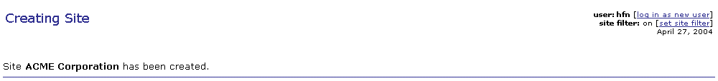

- After you finish entering the desired values for the above parameters on the Create User page you will have successfully created a new restricted user. Click on the button. The Creating User page will be displayed (See figure below).
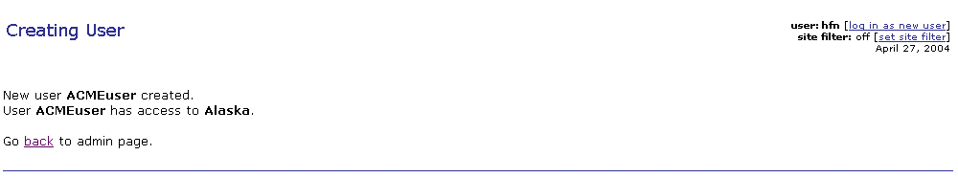
If you were not able to select a site for the new restricted user to access because the site name record on the ASI server had not been created (either manually or automatically when ASI client at the site started logging events and actions onto the ASI server), you should proceed to step 6) below.
- If you created the record for the new site by using the new site link as described above after you created the record for the new restricted user, you will need to give the new restricted user access to the site as follows:
- Clicking on the users link at the top of the Admin page, right under the ASI Server page logo, will take you to the Users area on the Admin page.
- Clicking on the [edit] link in the rightmost column entry corresponding to the name of the new restricted user (the user just created), will take you to the Edit User page (See figure below).
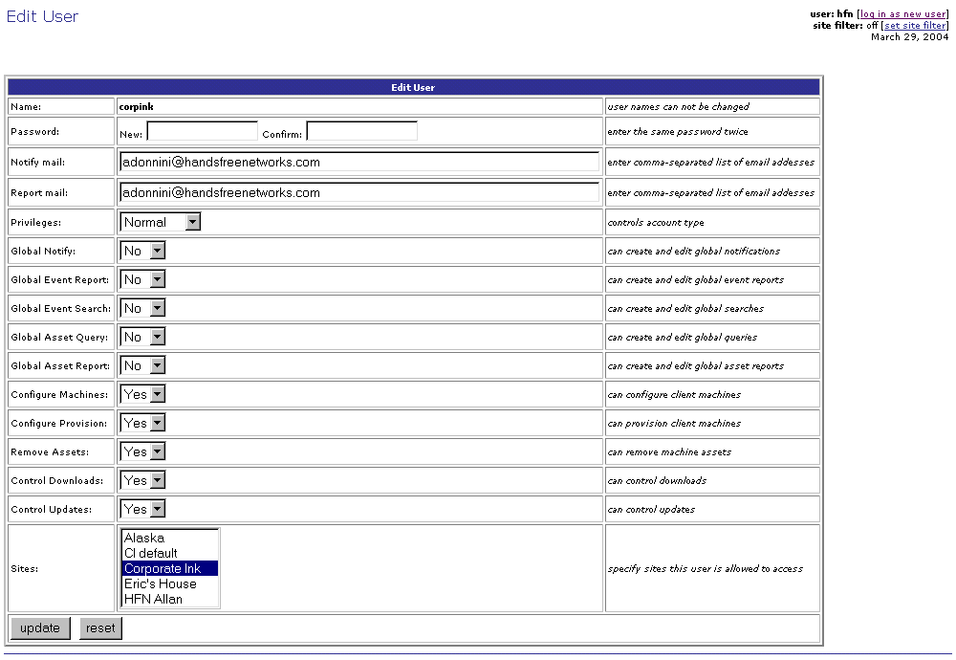
- Scroll down the list next to the Sites label until you locate the entry for the new site, and select it by clicking on it
- Click on the  button to complete the process. The Admin Updating User page will be displayed (See figure below).
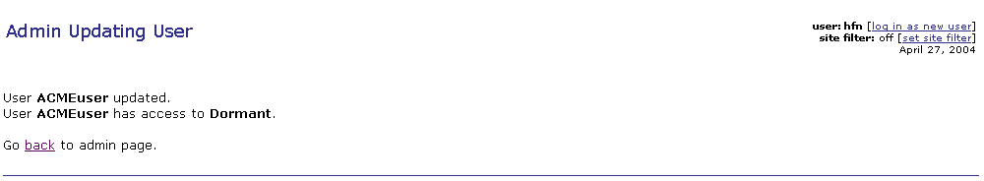
- You can go back to the Admin page by clicking on the back link on the page, or on the admin link at the top right-hand corner of any of the ASI server pages.

Defining and running asset reports for an asset survey and assessment
As mentioned in the Overview section of this document, there are a number of reports already defined that you can use as deliverables for the asset survey and assessment service. They include:
- Master Network Software List
- Network CD-ROM List
- Network Equipment Hard Drive List
- Network Equipment Hard Drive List - II
- Network Equipment Operating System List
- Network Equipment RAM Table
- Network Equipment Processor Table
- Software Inventory - All Devices
- Software Inventory - Servers
- Software License Numbers - All Devices
- Software License Numbers – Servers

Running an asset report
To run any of the reports listed above for a specific customer, you should perform the following steps:
- Log onto the ASI asset management report module on your ASI server as a user that can access only that customer’s site. This will ensure that any asset reports produced will contain only asset information from that customer’s systems. Open a browser window and type:
https://asiserverurl/main/asset/report.php
Substitute asiserverurl with the URL of the ASI server your sites log to.
To set up a user that can access only selected site(s), please refer to the User and Site Set-up User Guide.
- Enter your user id and password. After successfully logging on, the Asset Reports page will be displayed (See figure below).
Please note that you can reach the Asset Reports page clicking on the reports link located at the top right-hand corner of every ASI installation server page to the right of the assets: label, or on the reports link under the Asset Management header on the Welcome page of the ASI server.
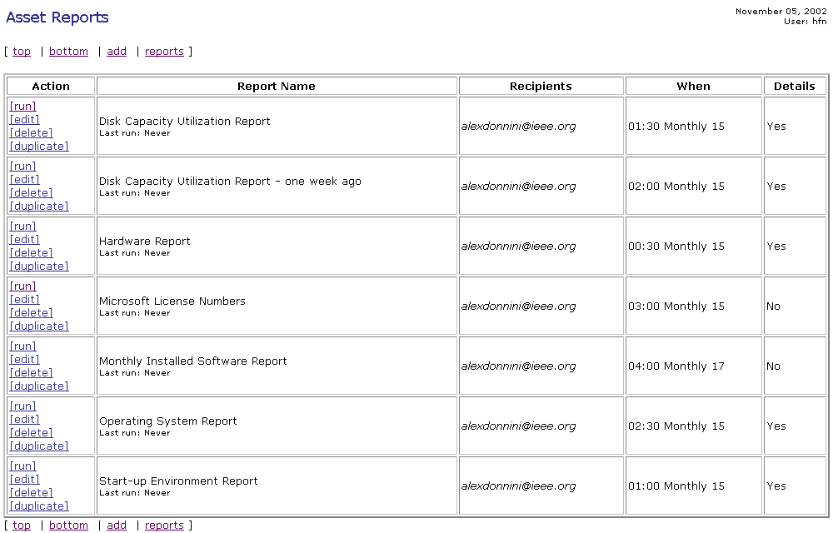
- Locate the name of the report you would like to produce, if necessary by scrolling down the window. Click on the [run] link to the left of the report name. The Asset Report Run page will be displayed (See figure below).
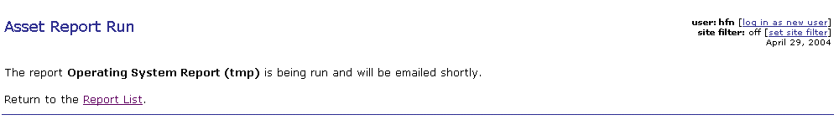
- Go back to the Asset Reports page. You will see an entry for a report with the same name as the one you ran, with a (tmp) appended to the name. The entry in the When column for this report will be immediate. This means that as soon as the report is either posted on the information portal, or e-mailed, its entry in the Asset Reports page will be deleted.
Alternatively, you could do the following:
- Locate the name of the report you would like to produce, if necessary by scrolling down the window. Click on the [duplicate] link to the left of the report name. The Duplicate an Asset Report page will be displayed (See figure below).
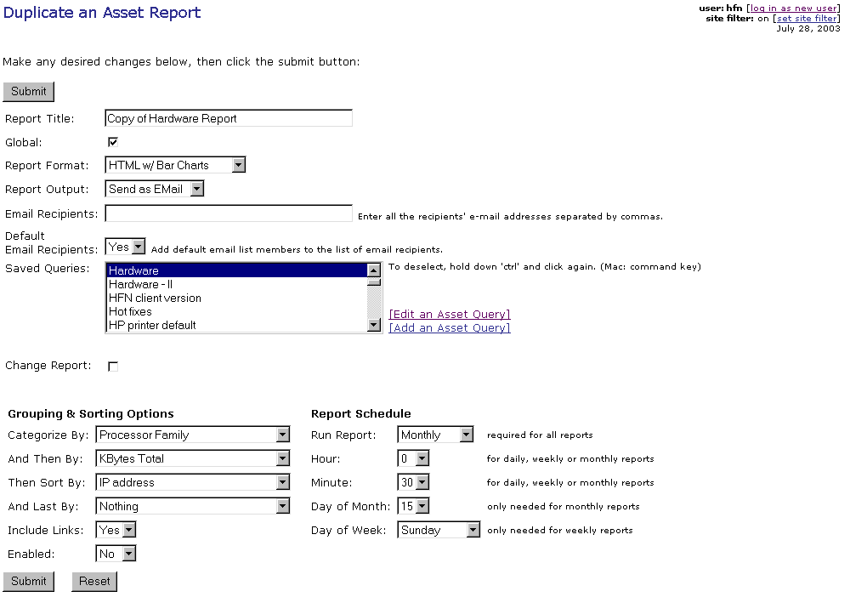
- Change the name of the report in the box to the right of the Report Title label to customize it for the customer you are preparing the report for.
- Change the report schedule to immediate by selecting Immediate from the pull down list to the right of the Run Report label. Click on the  button. The Asset Report Duplicated page will be displayed (See figure below).
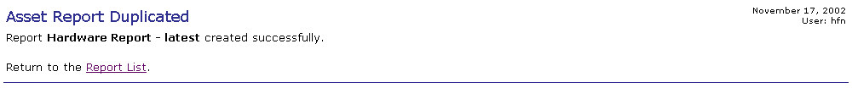
- Go back to the Asset Reports page. You will see an entry for the new report. The entry in the When column for this report will be immediate. This means that as soon as the report is either posted on the information portal, or e-mailed, its entry in the Asset Reports page will be deleted.

Customizing an asset report
Depending on customer requirements, from time to time you may want to change the information or the presentation format of reports produced for the asset survey and assessment service.

Changing the information contained in an asset report

Identifying the asset query used by a report
Asset reports use asset queries to retrieve asset information. In order to change the information contained in an asset report, you need to change the asset query it uses to retrieve asset information. First, then, you need to find out which asset query is used by the report that you want to customize. To do this, perform the following steps:
- Log onto the ASI asset management report module on your ASI server as a user that can create and modify global asset queries and reports. This will ensure that any customized asset queries and reports will be available to all users. Open a browser window and type:
https://asiserverurl/main/asset/report.php
Substitute asiserverurl with the URL of the ASI server your sites log to.
To set up a user that can create/modify global asset queries and reports, please refer to the User and Site Set-up User Guide.
- Enter your user id and password. After successfully logging on, the Asset Reports page will be displayed (See figure below).
Please note that you can reach the Asset Reports page clicking on the reports link located at the top right-hand corner of every ASI installation server page to the right of the assets: label, or on the reports link under the Asset Management header on the Welcome page of the ASI server.
- Locate the name of the asset report for which you want to identify the underlying asset query, if necessary by scrolling down the window. Click on the [edit] link to the left of the asset report name. The Edit an Asset Report page will be displayed (See figure below).
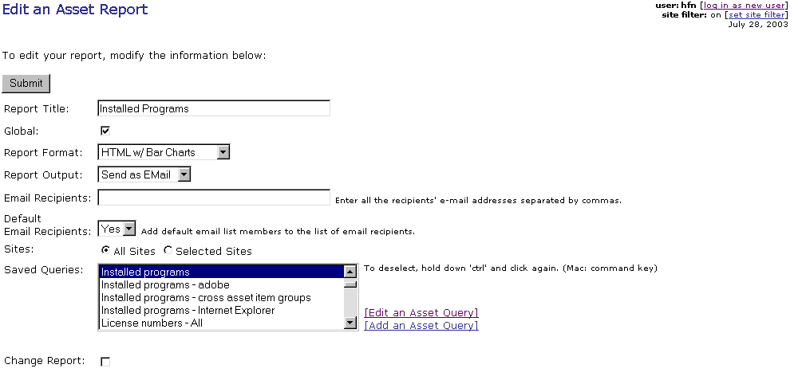
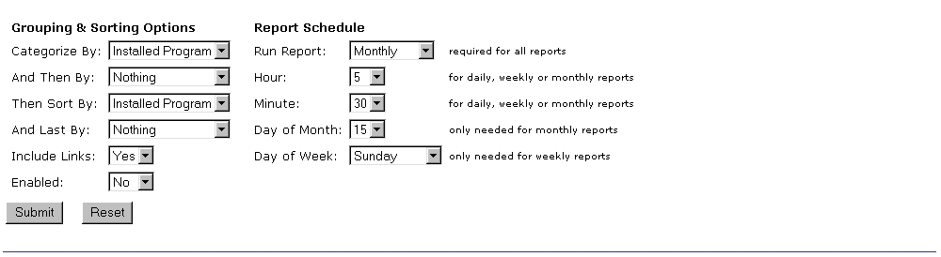
- Scroll down the list of entries in the box to the right of the Saved Queries label until you locate the entry highlighted in dark blue, taking care to not click on the entries in the list that would change the asset query used by the report. Make a note of the name of the highlighted asset query. Close the browser window, or click on the Back button on your browser.

Modifying an asset query
- Log onto the ASI asset management query module on your ASI server as a user that can create and modify global asset queries and reports. This will ensure that any customized asset queries and reports will be available to all users. Open a browser window and type:
https://asiserverurl/main/asset/query.php
Substitute asiserverurl with the URL of the ASI server your sites log to.
To set up a user that can create global asset queries and reports please refer to the User and Site Set-up User Guide.
- Enter your user id and password. After successfully logging on, the Asset Queries page will be displayed (See figure below).
Please note that you can reach the Asset Queries page clicking on the queries link located at the top right-hand corner of every ASI installation server page to the right of the assets: label, or on the queries: link under the Asset Management header on the Welcome page of the ASI server.
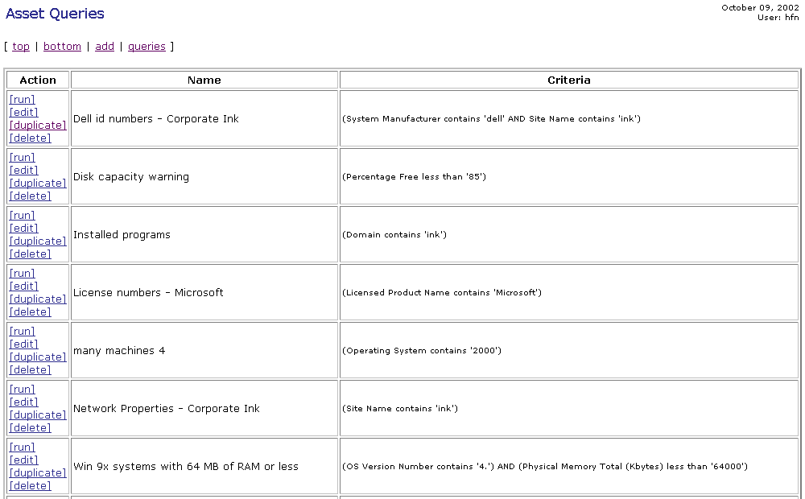
- Locate the name of the asset query that you want to modify, if necessary by scrolling down the window.
If you want to maintain the original asset query unchanged, you should duplicate it. Click on the [duplicate] link to the left of the asset query name. The Duplicate an Asset Query page will be displayed (See figure below).
If you want to change the asset query because, for example, you think that as currently defined you would not use it, you should edit it. Click on the [edit] link to the left of the asset query name. The Edit an Asset Query page will be displayed.
Since the Edit an Asset Query and Duplicate an Asset Query pages are essentially the same, and the steps you should perform to edit or duplicate an asset query are also the same, we will provide instructions for the case where you would duplicate an asset query.
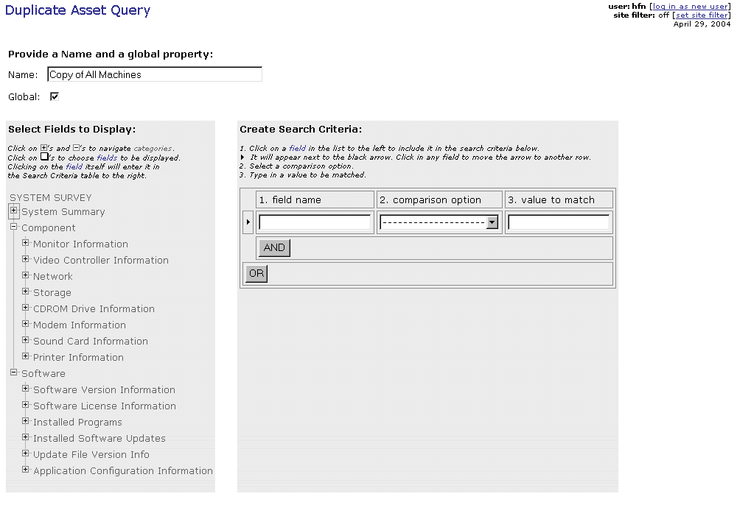
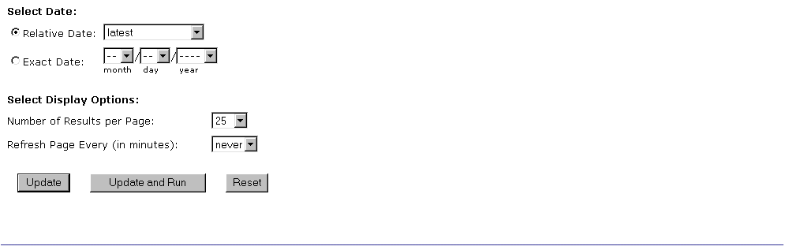
- Change the name of the asset query as displayed in the box to the right of the Name lable. Please note that by default when duplicating an asset query the name is changed automatically by adding Copy of at the beginning of the asset query name.
- To change the information retrieved by an asset query, expand the asset information tree in the Select Fields to Display area of the Duplicate an Asset Query page, by clicking on the symbols to expand the tree until you see the entry for the asset data field(s) whose content you want the asset query to retrieve. Then, click on the box to the left of the asset data fields you want the asset query to retrieve.
If you want to use an asset data field as a selection criteria, click on the field label for that field. The name of the asset data field will be automatically entered in the box under the field name header in the Create Search Criteria area of the Duplicate an Asset Query page. Next, select a comparison option from the pull down list under the comparison option header. Complete the search criteria creation by entering a value to use for selecting records in the box under the value to match header.
You can define multi-clause selection criteria joined by AND/OR clauses by clicking on the  or 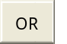 buttons and add selection criteria until you are done.
Once you have selected all the fields you want the asset query to retrieve, and the selection criteria, if any, for selecting records from the asset database, click on one of the , 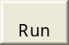, or  buttons to complete the asset query editing process.
You can find more information about the ASI asset management facility and asset queries in the Automated Support Infrastructure Asset Management User Guide. You can access this user guide online by clicking on the help link under the Tools heading on the Welcome page, or to the right of the tools: label on the upper right-hand corner on any page on the ASI server.

Editing an asset report to change the asset query it uses to retrieve asset information

If you changed the asset query used by the asset report you want to produce as part of the asset survey and assessment service, you are ready to run it performing the steps described in the Running an asset report section of this document. If you duplicated the asset query, or if you want to modify the report format, you should edit the report definition to incorporate these changes. To do this, you should perform the following steps:
- Log onto the ASI asset management report module on your ASI server as a user that can create and modify global asset queries and reports. This will ensure that any customized asset queries and reports will be available to all users. Open a browser window and type:
https://asiserverurl/main/asset/report.php
Substitute asiserverurl with the URL of the ASI server your sites log to.
To set up a user that can create/modify global asset queries and reports, please refer to the User and Site Set-up User Guide.
- Enter your user id and password. After successfully logging on, the Asset Reports page will be displayed (See figure below).
Please note that you can reach the Asset Reports page clicking on the reports link located at the top right-hand corner of every ASI installation server page to the right of the assets: label, or on the reports link under the Asset Management header on the Welcome page of the ASI server.
- Locate the name of the asset report whose definition you want to change, if necessary by scrolling down the window. Click on the [edit] link to the left of the asset report name. The Edit an Asset Report page will be displayed (See figure below).
- Scroll down the list of entries in the box to the right of the Saved Queries label until you locate the entry for the new asset query and click on it. At this point, if you don’t want to make any other changes to the report’s definition, the report definition editing process is completed. Click on the button. The Asset Report Updated will be displayed (See figure below)
- You can also change other elements of the report definition. Please refer to the Automated Support Infrastructure Asset Management Report Module User Guide for detailed information on report definition parameters. You can access this user guide online by clicking on the help link under the Tools heading on the Welcome page, or to the right of the tools: label on the upper right-hand corner on any page on the ASI server.
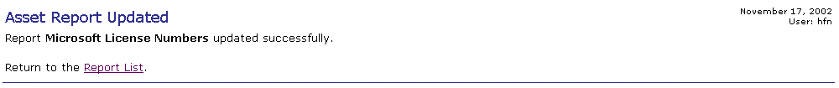
- At this point, you are ready to run the asset report following the steps described in the Running an asset report section of this document.

Base Scrip configuration list
- Scrip 1 – Client update
- Scrip 2 – Variable propagation
- Scrip 177 – Client/server variable synchronization
- Scrip 190 – Run as a service
- Scrip 186 – Scrip run limit (start multithreaded operation)
- Scrip 187 – Fill machine name cache
- Scrip 43 – Basic ASI client configuration
- Scrip 223 – ASI client initial setup (from generic installation)
- Scrip 18 – ASI client restart/shutdown
- Scrip 63 – Log ASI client startup
- Scrip 64 – Log ASI client shutdown
- Scrip 201 – ASI network driver management
- Scrip 99 – Debug
- Scrip 226 – CApp management

